How to Execute Dunning Wizard

To beginning the dunning wizard process got to: Sales –A/R Dunning Wizard

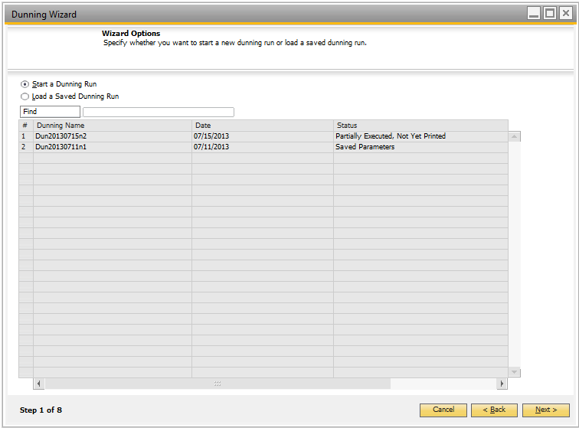

Click next to create a new Dunning Run or you may load a previous run by clicking on ‘Load a Saved Dunning Run’ and by choosing one of the previous runs and clicking next.

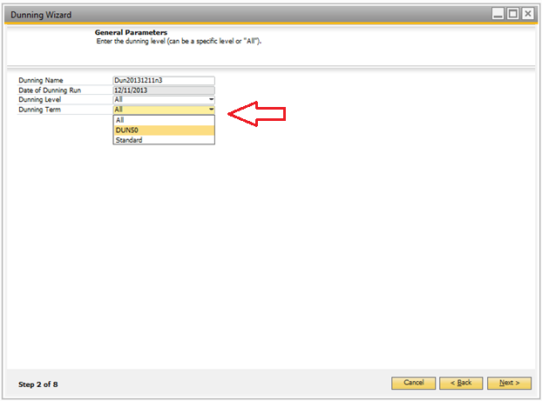

Next, you may choose some general parameters that will dictate the fee structure or Dunning Term for the Run. This is also the last step you may alter the ‘Dunning Name’ if need be – This will become the remarks for service type invoices created at the end of the run. By default, the dunning Run will include all levels 1 – 10. For this run, we will use a newly created ‘Dunning Term’ DUN50, which includes a $50 fee associated with the Dunning Notice -- Steps on how to create additional dunning terms are found in the Exhibit 1.1.

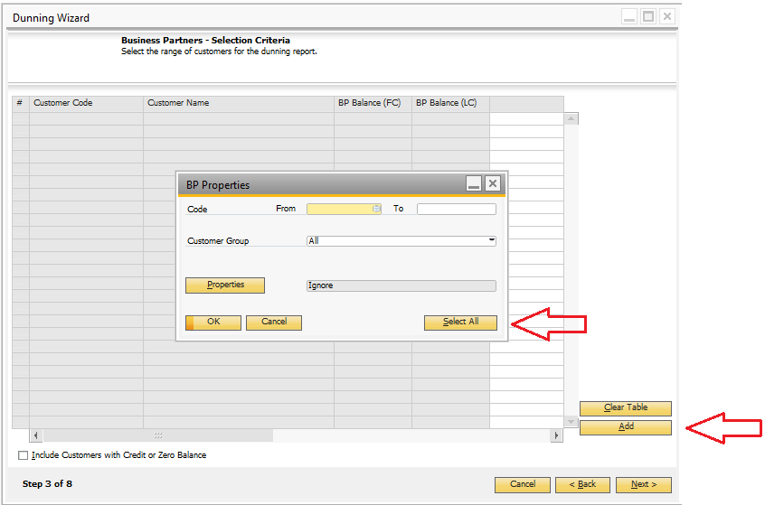

Next, click ‘Add’ ‘Select All’ ‘OK’ to create a table of business partners with outstanding balances that fit the criteria of the general parameters set in Step 2. Then click next when the table populates.

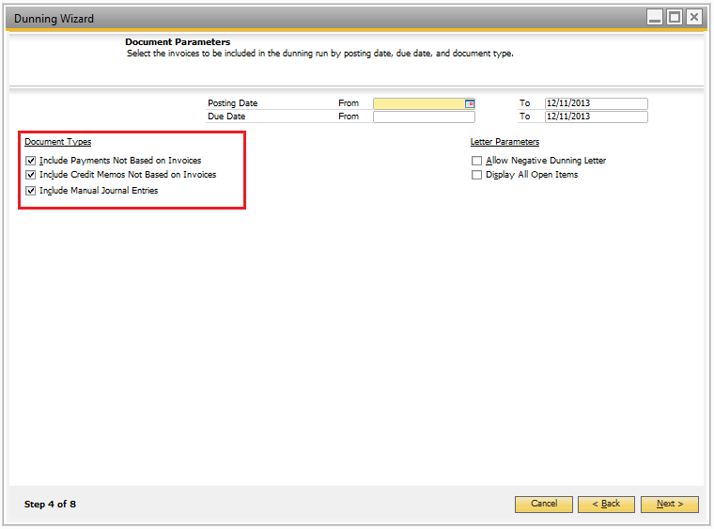

Next step is to select the Document Parameters associated with the Dunning Run. By Default, Posting Date and Due Date are set at the date of the Dunning Run. You may also alter the Document Types to be considered in the run in the Top left of the Wizard. Generally, it is best practices to include Incoming Payments on Account, Credit Memos not reconciled, and Manual Journal entries associated with BP’s. This will show what transactions need to be internally reconciled within a given BP to ensure timely and accurate information on the Dunning Letters.

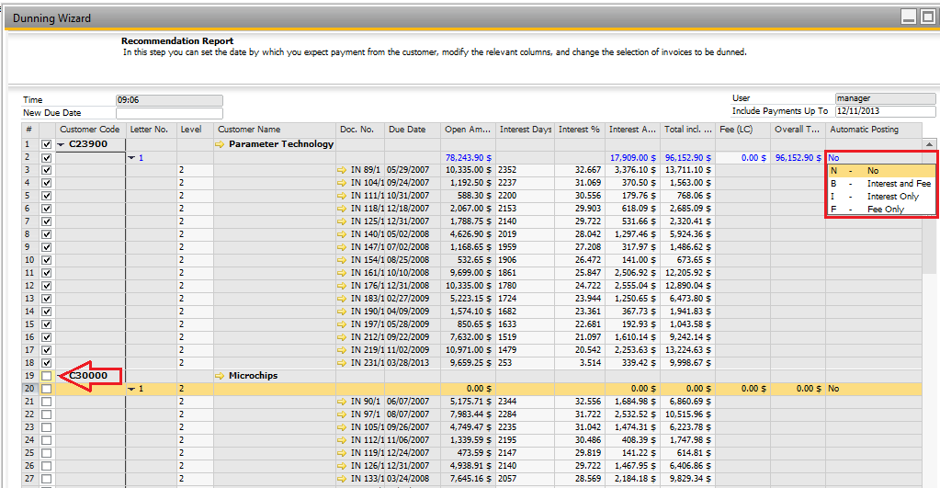

Next process of the Dunning Wizard is the Recommendation Report. Here you may choose which Business Partners to exclude, as well as the Dunning Terms associated with the account that will be reflected in the service type invoice automatically created at the end of the Dunning Run. In this example, I choose to exclude both BP’s shown from the run in two different ways -- First, the ‘Automatic Posting’ column is set to ‘No’ for the BP Parameter Technology and secondly by unchecking the box next to the BP Microchips Technology.

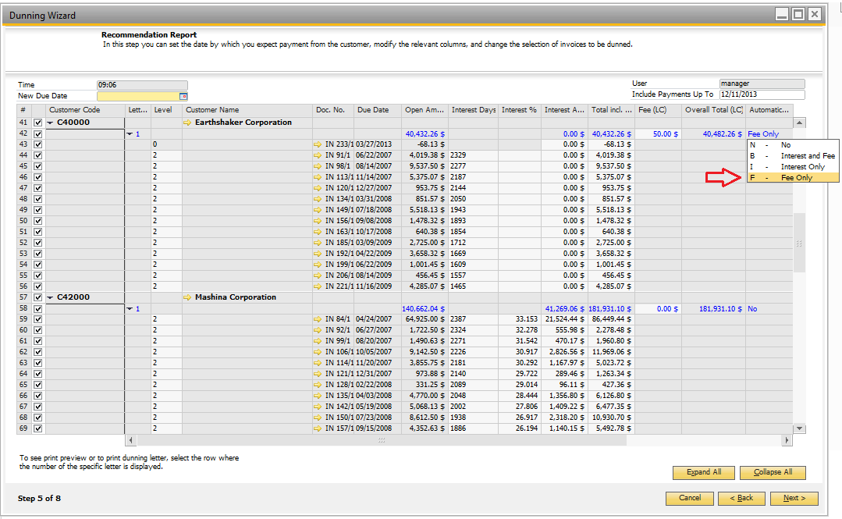

I have decided to include the Automatic Posting for the ‘Fee Only’ option for C40000. This will generate a $50 service fee associated with the Dunning Letter via a service type A/R Invoice for the Dunning Term that was created prior to the Run.

**Please Note** To incorporate the Fee with the selected BP, you must first alter the Payment Terms for that BP to include the newly added Dunning Term: Drill Down into the BP via the Recommendation Report click on the ‘Payment Terms’ tab then select appropriate term. From there you will be prompted to replace all associated dunning term settings automatically: Click ‘yes’ ‘update’ ‘ok’. See Below for greater detail.

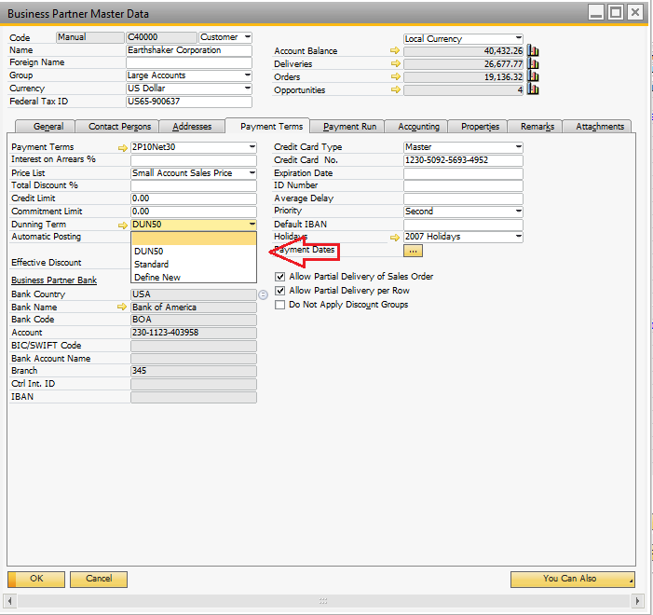

Once you have choosen which BP’s to exclude/include and dicated the Automatic Posting for BP’s you would like to include on the Dunning Run you may proceed to the next step. If you have foreign BP’s within your Dunning Paramenters, you will be prompted to associate appropriate exchange rates for the given time frame.

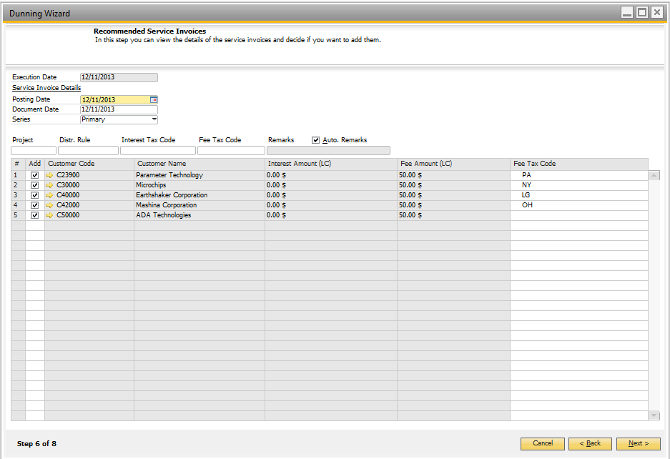

In Step 6, you may choose the Posting and Document date for the recommended Service Invoice as well as choose to exclude a BP for the last time via the ‘Add’ column checkbox on the left of the table. You must specify the ‘Fee Tax Code’ for the Service Invoice to successfully generate. Click next once this has been done.

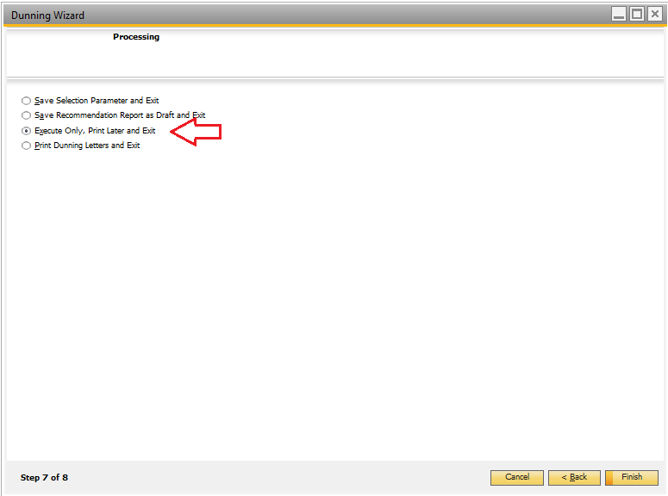

The Final step is to choose the processing type for the Dunning Run. Since I would like to Email the Dunning Letters, I choose ‘Execute Only, Print Later and Exit’. Click Finish to create the Service Invoices and complete the Dunning Wizard. You will be prompted to choose Yes or No for the services invoices to generate. Click ‘Finish’ once again when the Service Invoices successfully generate.

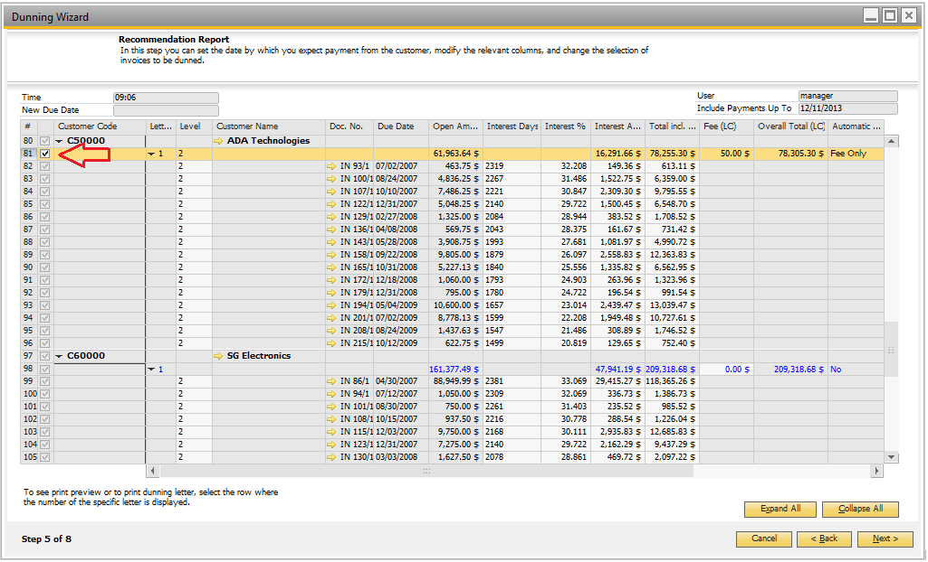

To email or create a PDF for the Dunning Letter you must load the previous dunning Run and proceed to Step 5 of the Dunning Wizard. From here, click on the row below the BP with the Letter Number and then click on the Email or PDF Icon located in the toolbar. This will email or create the Dunning Letter but not include the Service Type invoice associated with the BP’s Dunning Term.

